A000-Eur-Bulgaria-Neolithic Hamangia Culture-Venus Figurine-ca 5000 BCE

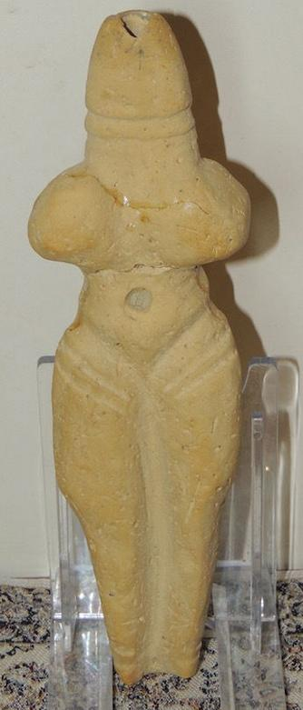 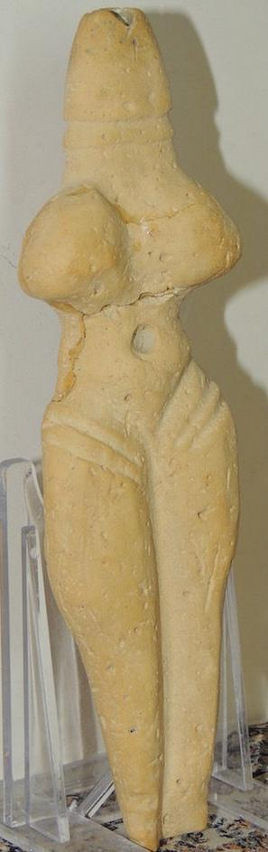 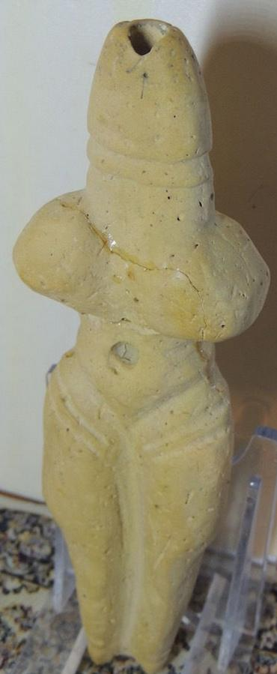

Formal Label:

Accession Number:

Date or Time Horizon: 5000 BCE

Geographical Area: eastern Bulgaria

Cultural Affiliation: **Hamangia culture**

Medium: sandstane

Dimensions: 17 cm

Weight:

Provenance: eastern Bulgaria

The **Hamangia culture** is a Late Neolithic archaeological culture of Dobruja (Romania and Bulgaria) between the Danube and the Black Sea and Muntenia in the south. It is named after the site of Baia-Hamangia, discovered in 1952 along Golovita Lake.[[1]](https://en.wikipedia.org/wiki/Hamangia_culture" \l "cite_note-1)

Pottery figurines are normally extremely stylized and show standing naked faceless women with emphasized breasts and buttocks. Two figurines known as “The Thinker” and “The Sitting woman” are considered masterpieces of Neolithic art.

Its cultural links with [Anatolia](https://en.wikipedia.org/wiki/Anatolia) suggest that it was the result of a settlement by people from Anatolia, unlike the neighbouring cultures, which appear descended from earlier Neolithic settlement.[[3]](https://en.wikipedia.org/wiki/Hamangia_culture" \l "cite_note-3)

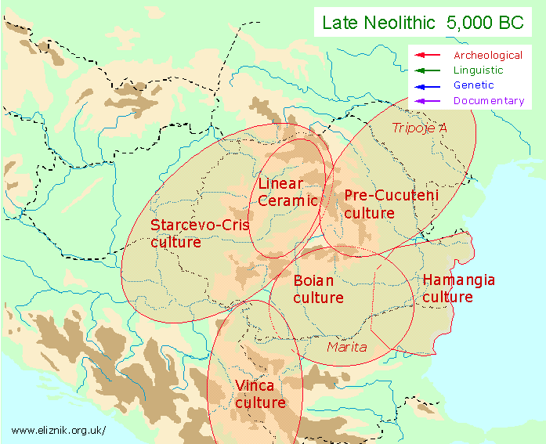

Map of the late Neolithic cultures of Bulgaria ca 5000 BCE

## References

1. • • [Dumitru Berciu](https://en.wikipedia.org/wiki/Dumitru_Berciu), *Cultura Hamangia. Bucureşti: Editura Academiei Republicii Socialiste România* (1966).
2. • • [Vladimir Slavchev, Monuments of the final phase of Cultures Hamangia and Savia on the territory of Bulgaria, *Revista Pontica* vols. 37-38 (2004-2005), pp. 9-20.](http://revistapontica.files.wordpress.com/2009/10/pontica-37-38-pag-9-20.pdf)
3. • M. Nica, [Unitate şi diversitate în culturile neolitice de la dunărea de jos = Unity and diversity of Neolithic cultures along the lower Danube](http://cat.inist.fr/?aModele=afficheN&cpsidt=2023910), *Revista Pontica* vol. 30 (1997), pp. 105-116.

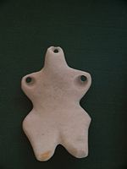

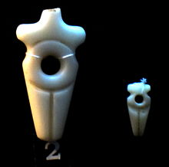

Gumelnita figurine